**Computer Networks Lab Report**

**Assignment-** 6

**Class:** BCSE-III

**Semester:** 1st

**Group:**  A3

**Group Members:-**

* PARTHIV SARKAR - 002110501134
* ARKAJYOTI NASKAR - 002110501144
* SOHAM CHOWDHURY - 002110501145
* ARIYAN BHAUMIK - 002110501149

**Problem Statement: Use Cisco Packet Tracer software to do the following experiments.**

1. **Connect two hosts back-to-back with a crossover cable. Assign IP addresses, and see whether they are able to ping each other.**

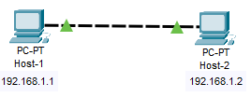

Host-1 pings Host-2:-

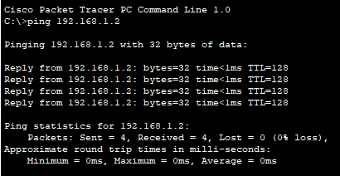

Host-2 pings Host-1:-

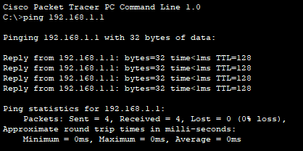

1. **Create a LAN (named LAN-A) with 3 hosts using a hub. Ping each pair of node**

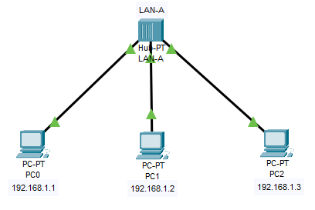

PC0 pings PC1:-

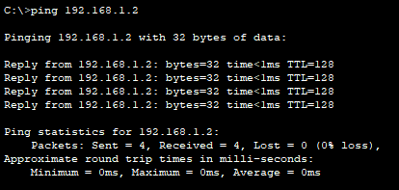

PC0 pings PC2:-

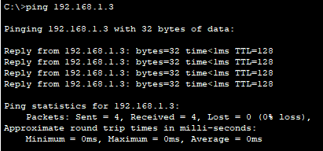

1. **Create a LAN (named LAN-B) with 3 hosts using a switch. Record contents of the ARP Table of end hosts and the MAC Forwarding Table of the switch. Ping each pair of nodes. Now record the contents of the ARP Table of end hosts and the MAC Forwarding Table of the switch again.**

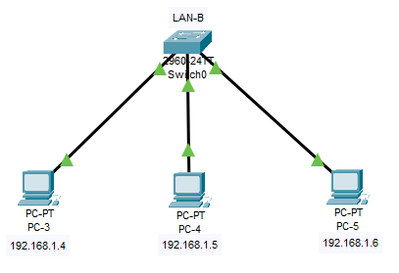

**Before pinging**:-

Arp table of PC3



Arp table of PC4



Arp table of PC5



Arp table of Switch-0



PC3 will ping PC4

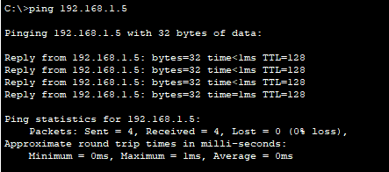

PC3 will ping PC5

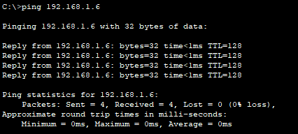

**After pinging**:-

ARP table of PC3

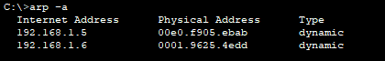

ARP table of PC4

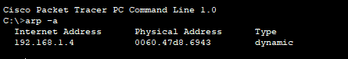

ARP table of PC5



ARP table of Switch-0

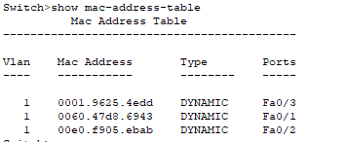

1. **Connect LAN-A and LAN-B by connecting the hub and switch using a crossover cable. Ping between each pair of hosts of LAN-A and LAN-B. Now record the contents of the ARP Table of end hosts and the MAC Forwarding Table of the switch again.**

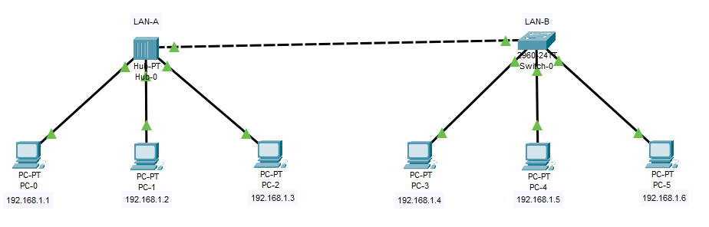

**PCO pings PC5**

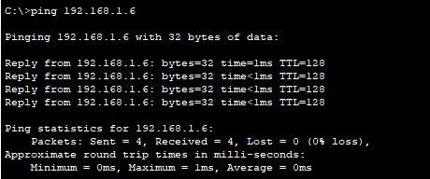

ARP table for PC0

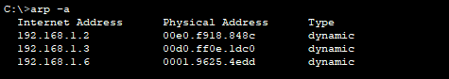

ARP table of PC5

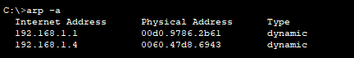

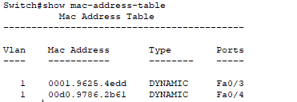ARP table of Switch-0

1. **Create a LAN (named JU-Main) with three hosts connected via a layer-2 switch (Cisco 2950 switch PC-LAB1-Switch). Connect the switch to a router (Cisco 1818). Assign IP addresses to all the hosts and the router interface connected to this LAN from network 192.168.148.0/24. Configure the default gateway of each host as the IP address of the interface of the router which is connected to the LAN.**

**Create another LAN (named JU-SL) with three hosts connected via a layer-2 switch (Cisco 2950 switch PC-LAB2-Switch). Connect this switch to another router (Cisco 1818). Assign IP addresses to all the hosts and the router interface connected to this LAN from network 192.168.149.0/24. Configure the default gateway of each host as the IP address of the interface of the router which is connected to the LAN. Connect the two routers through appropriate WAN interfaces. Assign IP addresses to the WAN interfaces from network 192.168.150.0/24. Add static route in both of the routers to route packets between two LANs.**

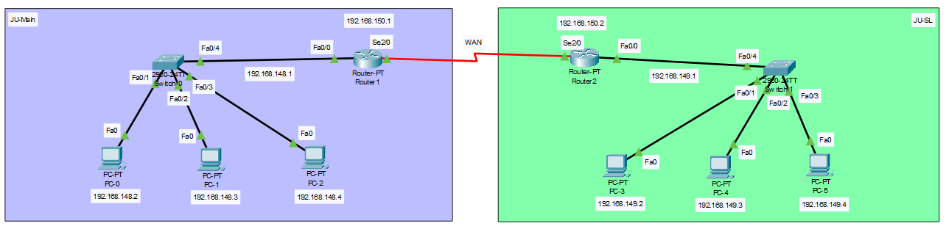

PC-0 and PC-1 is in JU-Main LAN

**PC-0 pinging PC-1 : Successful**

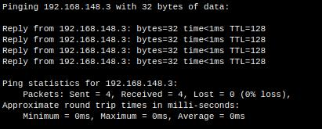

PC-0 is in JU-Main LAN and PC-4 is in JU-SL LAN

**PC-0 [192.168.148.2] pinging PC-4 [192.168.149.3] : Successful**

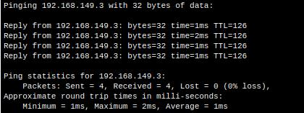

1. **Add servers to the individual LANs (in problem 5) and configure them as a DHCP server. Configure the hosts in the individual LAN to obtain IP addresses and address of the default gateway via this DHCP server.**

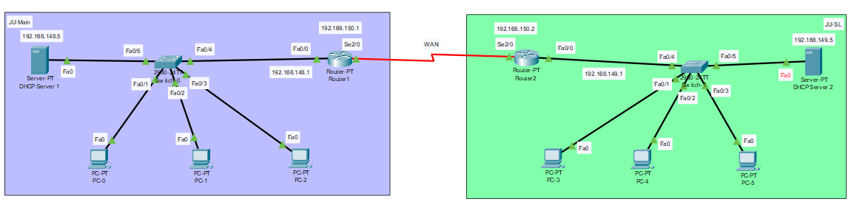

DHCP Server 1 is working. As we can see, DHCP Server has allocated **IP-192.168.148.3 to PC0.**

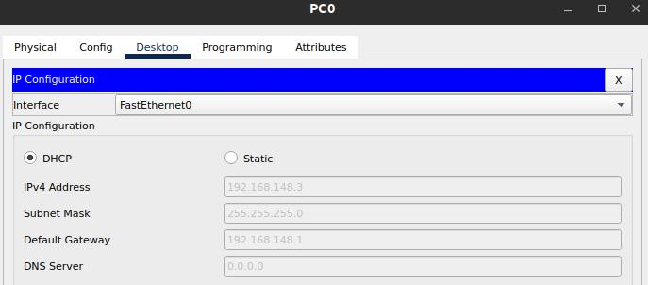

DHCP Server 2 is also working. As we can see, DHCP Server 2 has allocated **IP-192.168.149.4 to PC3.**

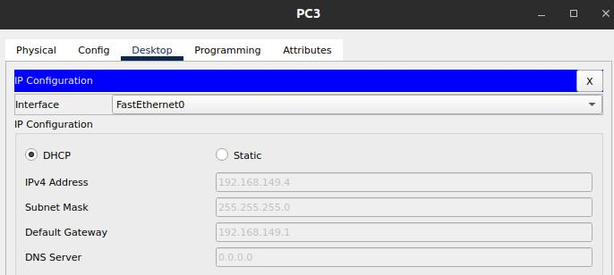

1. **Create a LAN (CSE) with three hosts connected via a layer-2 switch (Cisco 2950 switch CSE-Switch). Also add a web server and a ftp server to this LAN. The hosts dynamically get their IP addresses from a local DHCP server. Servers are assigned fixed IP addresses. Configure the individual hosts to use the local DNS server for name resolution. Add a Domain Name Server (DNS) to this LAN. Create appropriate records in the DNS server for the individual servers in the LAN. The domain name of the LAN is cse.myuniv.edu. Configure the individual hosts to use the local DNS server for name resolution.**

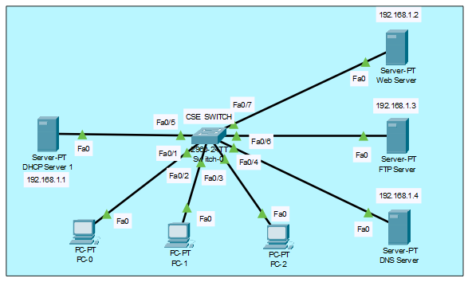

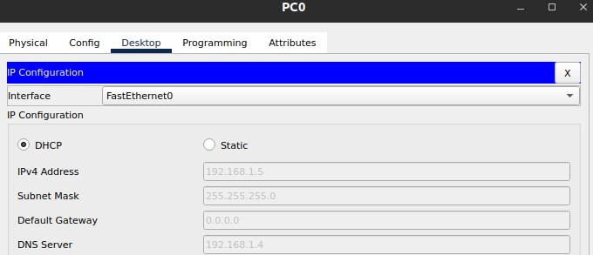DHCP Server has allocated **192.168.1.5 to PC0**

**DHCP Server has allocated 192.168.1.7 to PC1**

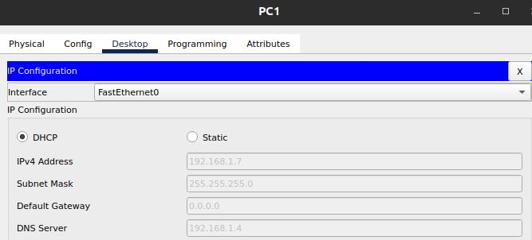

DHCP Server has allocated **192.168.1.6 to PC2**

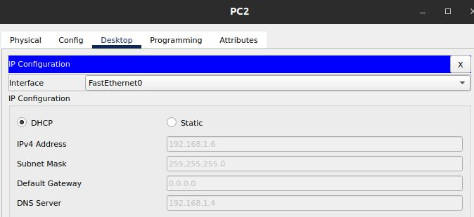

**DNS Server : 192.168.1.4**

**FTP Server : 192.168.1.3**

**Web Server : 192.168.1.2**

**DNS Server Configuration**:-

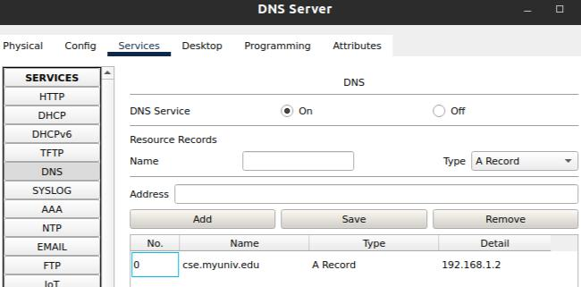

From PC0 accessing **cse.myuniv.edu**

